**A Viable Future: Attracting the Youth Back to Agriculture**

A Regional Scoping

Paper Prepared by

Asian Farmers Association for Sustainable Rural Development (AFA)

August 2015

**Abstract**

Youth is often the time when a person starts to dream of the future, think of the path to take and boldly and aggressively set his/her life in motion. In many rural villages, to be a farmer is not part of this dreamt future. Farming is a lowly job and does not earn, so better migrate to cities or abroad where there may be more opportunities and adventure. What will then be the future of agriculture and food without young farmers? No farmer, no food. No food, no life. In this scoping paper, we will discuss why young people are not attracted to agriculture, what are the initiatives being taken to encourage the youth to be in agriculture, and what are the recommendations for the youth to stay in it.

**TABLE OF CONTENTS**

|  |  |
| --- | --- |
|  | Page |
| Abstract | 1 |
| I. INTRODUCTION | 3 |
| II. WHO ARE THE YOUTH AND WHAT ARE THEIR MAIN CHALLENGES? | 4 |
| III. YOUTH IN RURAL AREAS | 5 |
| IV. WHY AGRICULTURE IS NOT ATTRACTIVE TO THE YOUTH | 7 |
| V. CHALLENGES FACED BY YOUNG FARMERS | 9 |
| VI. AFA INITIATIVES TO ATTRACT THE YOUTH BACK INTO FARMING | 10 |
| VII. AFA POLICY PROPOSALS TO ATTRACT YOUTH BACK INTO FARMING | 17 |
| VIII. WHAT CAN OUR GOVERNMENTS DO TO ATTRACT THE YOUTH TO AGRICULTURE AND MAKE THEM STAY? | 19 |
| IX. WHAT CAN AFA DO TO PROMOTE AGRICULTURE AMONG THE YOUNG? | 20 |
| X. CONCLUSION | 21 |
| REFERENCES | 22 |

**I. INTRODUCTION**

The United Nations (UN) declared 2014 as the International Year of Family Farming (IYFF) to recognize the significant contribution of small-scale farmers in feeding the world and caring for the earth. The IYFF is an opportunity to tell the world to invest in smallholder agriculture, invest in women in agriculture and invest in the rural youth. Small scale family farmers feed 70% of the world’s population and a majority of them are in Asia and Pacific, while 60% of the poor and hungry people are in Asia.

The discussions in this scoping paper is a consolidation of: a) the results of the national consultations and participatory researches conducted by AFA members in 9 countries involving around 660 rural youth on the issue “attracting the youth to agriculture” using the Farmers Advocacy Consultation Tool (FACT) developed by Agriterra (see Annex A); b) the results of the regional consultation involving 30 men and 10 women representatives, from 17 national farmer organizations in 13 countries held last May 2014; and c) desk research and literature review. AFA conducted these consultations during the celebration of the International Year of Family Farming (IYFF), since youth in agriculture is one of its IYFF priority issues.

In November 2014, the participants at the *AFA Young Farmers Regional Forum and Workshop* in Manila agreed to create an ad hoc structure. They see farming as a mission, a way of life, an important foundation of a society, and an essential element of a healthy society that should be nurtured and be an important heritage from their predecessors. Their vision statement is: “*A community of educated, empowered and passionate Young Asian Farmers engaged in sustainable family farming that nurtures a prosperous, resilient, healthy, happy and loving world.”* It is hoped that this structure will establish a strong base of organized young farmers within AFA.

Since 1990, the global context of land reform has transformed small-scale farming to large-scale farming and market-led land reform (Borras, 2006: 99). Current reforms are focused on modernization of agriculture rather than on distribution of land and tenure security of tillers, including young farmers. Those who cultivate the land are deprived of ownership; those who own land do not cultivate. Seizing land from farmers and handing this over to private owners, especially land plotters or industrialists, escalate the youth de-peasantization (Kumar, 2011).

Special economic zones of all sorts of privatization for the process of urbanization treat land as a commodity to be freely bought and sold in the market place (Kumar, 2011). Due to market-oriented land and agrarian reform, the price of land increases. Peasant culture and peasants are not independent from the framework of the ruling class. Land banking promotes land markets and the removal of peasants from the land. It has become a tool to control land and make it a commodity determining who can buy, sell and make profit (Hu, Yeh, Wu, 2009).

Moreover, the formal credit system and commercial banks supported commercial farming, destroyed peasant economy and family farming, and established a market economy (Harvey, 2003:156-166). The price of agricultural products is controlled by the market, not by the peasant or state. There is lack of transparency in price-setting, trade agreement, and policy formulation (Ahmad et al, 2010:37).

**II. WHO ARE THE YOUTH AND WHAT ARE THEIR MAIN CHALLENGES?**

The current generation of youth, defined by the United Nations as those aged 15 to 24, is the largest in history. As of 2012, the youth make up 1.8 billion or 18% of total world population. Ninety percent (90%) of these young people live in developing countries, comprising as much as 20% of their countries’ total population.

Many countries have their own age definition of youth, depending on specific socio-cultural, institutional, economic and social factors. Youth is defined under the law as young men and women, 12-24 years old in Taiwan; 14-28 in Kyrgyzstan; 15-25 in Thailand; 15/16-30 in the Philippines, Cambodia /Indonesia, Vietnam;15-34 in Mongolia; 15-40 in Nepal and Myanmar; 18-35 in Bangladesh; 9-24 in South Korea and 0-30 in Japan.

UN-ESCAP (2012) data show that over 60% of the world’s youth or more than 750 million live in Asia-Pacific (Fig. 1). In 2010, India registered the highest number of young people in the world at 234 million, or 19% of the country’s total population. China registered the second highest at 225 million, or 17% of its total population. Bangladesh and the Philippines had young people constituting 20% of their total populations. Japan had 12 million young people or 10% of its total population.

**Fig. 1. Distribution of youth in Asia Pacific, by subregion (2010)**

Source: <http://www.unescap.org/resources/youth-asia-pacific>

Some AFA members reported data on youth in their countries. In Nepal, nearly half of the population are youth 16-40 years, while those 18-35 comprise 42%. In Mongolia, 39% of the total population of 2.9 million are youth 15-34 years, with 41% women. In Kyrgystan,youth 14-28 years consist 31% of the population (or 1.6 million), and two-thirds live in rural areas.

According to UN-ESCAP (2012), several challenges beset the youth today:

1. **Lack of focus on the youth.** Youth issues in the region have not been tackled adequately due to several factors: a) lack of reliable data concerning youth; b) insufficient political will and earmarked resources; and c) lack of coordination among government ministries and involvement with NGOs, the private sector and academia.
2. **High rate of youth unemployment.** The average rate of youth unemployment is estimated at 11%, or more than double the rate of the total working age population. For young people, jobs do not only provide a source but also dignity and self-respect.
3. **High rate of youth migration.**Many young people choose to migrate to seek better lives. In Asia, the proportion of adolescent and youth migrants in the total international migrant population is 19%, while 46% of all migrants 10-24 years are females. Many youth migrants are undocumented or trafficked for sex work.

Data collected by AFA members show similar patterns of migration:

* In Vietnam, the number of youth who want to migrate to big cities to work increased from 40% in 2009 to 56% in 2012.
* In Nepal, there is high rate of youth migration to other countries (1,200-1,700 youth daily); in two districts surveyed, 5-25% of the rural youth have migrated abroad to look for employment.
* In Kyrgystan, 20% of the population are now out of the country, with most young people going to Russia and Kazakhstan.
* In the Philippines, most rural families want their children to pursue more gainful jobs in the cities or overseas, as farming is largely associated with poverty.

1. **Lack of national youth policies.** While some countries have well-developed and stand-alone national youth policies which are embedded in their constitutions, others still lack coherent youth policies with various government agencies responsible for covering different youth issues. Only a few national youth policies have been developed and implemented that draws upon the specific needs of young people.
2. **Limited role of youth in decision-making processes.** Youth in Asia face the continuing challenge of limited role in decision-making processes due to a lack of structured and institutionalized opportunities. Through social media, access to information and other new networking tools, young people across the region have better opportunities to become more politically active and find space for the realization of their aspirations.

**III. Youth in rural areas**

The youth make up 60% of the world’s rural population. In sub-Saharan Africa and Asia, up to 70% of the youth live in rural areas, and over half of those in the labor force engage in agriculture.[[1]](#footnote-2)

Moreover, FAO and UNDP data show that the percentage of rural youth in Asia has been decreasing over the past sixty years (Fig. 2).[[2]](#footnote-3) In 2010, rural youth in East Asia and Southeast Asia comprise 9% and 11% of the total population, respectively.

**Fig. 2. Rural youth (15-24 years) as % of total population by subregion (1950-2050)**

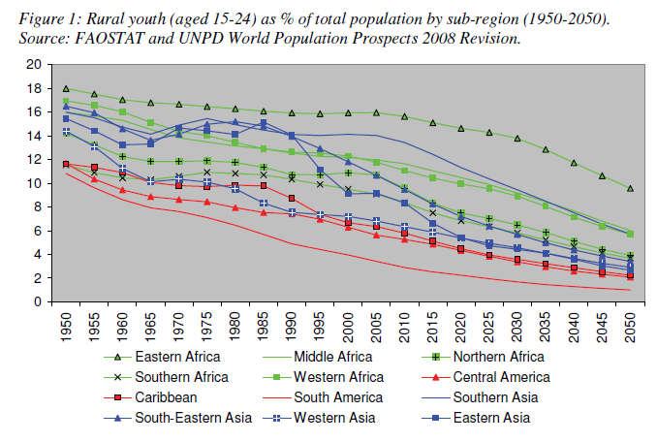Source: <http://www.fao.org/docrep/012/al414e/al414e00.pdf>

AFA members reported the following data on rural youth in their countries:

* In Vietnam, 30% of the population are youth 16-30 years, and 70% of them (or 17 million) are rural youth, with equal proportion of young men and women.
* In Kyrgystan, *t*he economically active section of rural youth 18-35 years and owning farming land and engaged in farming can be considered as “young farmers”. Young men and women in agriculture make up approximately 61% and 39%, respectively, of the 356,000 family farmers in the country. However, there are no records on young farmers and gender proportion in youth farming, and hence impossible to give official data relevant to youth in agriculture. There are 855,000 economically active youth, or 50.7% of the population, with 61.2% men and 38.9% women.
* In Mongolia, only 10% (or 117,700) of the total population are young herders, a critically low number for a country whose main economic sector is livestock, while 39% of the 25,000 crop farmers are young farmers, and 37% of them women.

For many decades, the rural youth have been under-tapped and neglected by their communities, governments, and international organizations, and thus are unable to make full use of their energy and potentials in the agriculture sector. The rural youth is often unemployed or work informally in unpaid or underpaid, low skilled, insecure and hazardous jobs. The lack of opportunities and decent jobs in the rural areas compel the youth to migrate to cities. Sons and daughters of farmers are often reluctant to go into farming due to various reasons. Many of those who continue to stay in the farms were often forced or did not have better options.

All these factors have resulted in another problem: ageing of the farming population. The next generation of family farmers of farmers is at risk with the ageing farming population in many countries in Asia. For instance, the average age of farmers in the Philippines, Thailand and Japan are 57, 54 and 66 years, respectively. Time-tested and traditional methods of farming are no longer being passed down by elders to the youth, which means this source of best practice exchange is slowly disappearing from the rural community’s way of life.

If the youth is the future of the nation, and the rural youth is the future of agriculture and rural industry, how can we then attract the youth to stay or work in the rural areas? What kind of policies and programs are needed to make them see that a good future awaits them and then decide to stay, by choice, in agriculture and rural industry?

(Please see Annexes B-M for more information on the situationer and initiatives on young farmers in 12 AFA member countries.)

**IV. WHY AGRICULTURE IS NOT ATTRACTIVE TO THE YOUTH**

From the results of national and regional consultations among young farmer leaders of AFA member organizations as well as from literature review, we can state seven (7) interrelated reasons why many of the youth, even the sons and daughters of farming families, will not farm, even if given a choice:

**i) Low regard for farming**. Farming is regarded as a lowly, back-breaking, unglamorous, dirty job needing little skills. There is usually less pride and dignity associated with farming.

In the Philippines, is perceived as lowly work fit only for school drop-outs or those without other options in life. In Bangladesh, there is “no dignity” in the farming profession, while farming is not seen culturally as a “respectable” profession in Nepal. Agricultural producers and peasants are always ranked low in developing countries and are defined as uneducated or uncivilized (Shrestha, 2001:114-115).

This low regard for farming is reinforced in society. Farmers tell their children: “Do not be like me, just a lowly farmer.” “If you don’t study well, you will just end up here, farming”. “You are not a bright student, go back to the field and just plant sweet potato.” Many schoolchildren dream to be doctors, engineers or lawyers, but seldom to be farmers.

**ii) Farming is not seen as a profitable job.** Majority of farmers are poor. They do not gain enough income from agriculture and are far from meeting their family and personal needs. Rural youth do not see farming as a way out of poverty; their parents were poor farmers, they will remain poor farmers. The popular perception is that there is no money in farming and agriculture is an outdated field with minimal financial returns. In Vietnam, rural youth would wish to farm only if farming would make them rich and secure. In Mongolia, young farmers said they needed to earn at least subsistence wages from farming.

Decreasing incomes due to increasing cost of agricultural labor and inputs such as seeds, fertilizers, and pesticides, low prices of produce, lack of control over their markets and high risks in agriculture brought by unpredictable weather conditions and price fluctuations keep the youth away from agriculture. Subsistence-oriented farming discourages young people, to engage in agriculture. Seeing family consumption as the only benefit of farming, the youth do not see any future prospects in farming.

**iii) Insecure land ownership and increasing land price.** Agrarian issues (e.g., insecure land tenure, landlessness) are major factors why the youth us not attracted to agriculture. Many young farmers either do not own the land that they cultivate, or those who want to farm lack agricultural land. In Cambodia, for instance, young farmers say they need to have knowledge on land titling so they can get secure land titles. Most agricultural lands are in the hands of medium and big farmers who are mainly absentee farmers. Rich people and corporations are also grabbing agricultural lands. Moreover, increasing industrialization and modernization has made agricultural lands decrease rapidly and has been one reason why the youth go to big cities and look for jobs.

**iv) Lack of rural infrastructure.** The base of agriculture remains in the rural areas. There is, however, a lack of good infrastructure and institutions to attract the youth to stay in the rural areas. In developing countries, most rural areas do not have good access to roads, electricity, health centers, clinics and hospitals, schools and universities, entertainment and amusement parks, internet connections, business establishments, markets to sell their agricultural produce as well as facilities for small and medium scale agro-industries or factories. Kyrgystan, for instance, suffers from shortage of water supply and poor irrigation structures in some areas.

**v) Lack of supportive government policies and programs for family farmers.** Many governments in developing countries give priority to corporate farming rather than family farming. Thus, the agriculture policies and programs in developing countries are not completely supportive of family farmers, despite the fact that they comprise the majority of farmers in the country and in the Asian region as a whole. Thus, many farmers still lack land, credit/financing, and markets.

There is a lack of exposure and skills training for young farmers, and generally, a lack of support for agricultural inputs, fertilizers, local seeds, modern agricultural equipments, access to capital, lack of information on price or market. Where agricultural support services are provided, these are inadequate or do not prioritize the needs of young farmers. Without these needed support, young smallholder farmers feel that they cannot compete with big commercial farmers.

**vi) Lack of curriculum on land, agrarian reform and agriculture.** Agriculture is the major source of employment in many developing countries. School and university curricula in these countries, however, do not include land and agriculture, resulting in the neglect of land and agrarian reform, thus discouraging young farmers to pursue an agricultural career. For instance, a recent study by the Southeast Asian Regional Center for Graduate Study and Research in Agriculture (SEARCA) has identified some major challenges to agricultural human resources across Asia as follows: a) aging agriculture research and academic staff; b) high staff turnover, wide age and qualifications gap in the succession hierarchy; c) low budget for research and training activities; d) outdated curricula, outmoded research and academic facilities; e) lack of student attraction to agriculture careers; and f) agriculture graduates not well-equipped with knowledge, skills and attitudes to compete globally.

**vii) Lack of organizations of young farmers**. At local, national and international levels, there are very few organized groups of young farmers for solidarity, exchange of information and ideas, for supporting each other’s endeavors and for representing their interests in decision-making bodies. Young people see rural life as boring that lacks social life and recreation activities. There are not may rural youth organizations that could foster community social activities and provide solidarity groups or venue for e.g., exchange of information, ideas and support among young farmers. Youth have also become disenchanted towards agriculture because of a lack of role models to motivate them.

**V. CHALLENGES FACED BY YOUNG FARMERS**

The youth who are engaged in farming face many challenges as young small-scale farmers, foremost of which are:

**i) Lack of access to and control over productive resources (land, capital, seeds, etc) and markets.** First, there is no land and agrarian reform focusing on young farmers in many Asian countries. As a result, most young farmers do not have access to lands for commercialization of their traditional farming (Wobst, 2010). They are landless, and often perform seasonal agriculture labor. Second, many young farmers have to wait until they inherit the land from their parents. While they still work under their parents’ wings, they have little decision over farming matters. Third, there are almost no banks and financial institutions that serve the agricultural sector and if there are, their understanding of the needs of young entrepreneur farmers is weak. Fourth, many young farmers have not yet established their markets.

For instance, young small-scale farmers lack access to credit since many of them are not the heads of families which are a legal requirement or they do have the collateral needed by banks and financial institutions, as these assets would usually still be in the names of their parents. Usurious rates or high interest rates on agricultural bank loans are also a major stumbling block, e.g. in Korea.

**ii) Inadequate skills and knowledge on production, processing, and business.** Young farmers lack experience, training and technical knowledge and skills to make farming more productive, e.g., agricultural technology, farm management, agri-enterpise business development and marketing. If skills trainings are provided, young women farmers would have less access as women are not largely seen as farmers. The current generation of young farmers has limited agricultural knowledge and skills as well as leadership and managerial skills (IIED, 2012:31). Skills development and technology transfer are considered the key to ‘model youth farming'. However, these have not been incorporated in government programs and school curricula. The youth prefer new technologies but many institutions do not understand their aspirations. Consequently, due to a lack of encouragement, support and promotion of adequate knowledge and skills especially in technology and modernization of farming, young farmers do not see any future in agriculture (Wobst, 2010).

**iii) Globalization, uncertainties, and variability in prices.** In some Asian countries, due to low tariff or open system for agriculture products, young farmers cannot compete with their products and are compelled to leave their farms. Instability in agricultural price is another factor. Due to low or no tariff in agriculture products, foreign products seem cheaper, making local products look expensive. People prefer cheaper goods to expensive ones. Due to various free trade agreements (FTAs) signed by governments (e.g., South Korea, Japan) some smallholders suffer loss, compelling them to leave farming.

Farming does not generate good returns on investment due to the high costs of agricultural inputs (e.g., chemical fertilizers, insecticides, seeds) and the low price of agricultural products. Farming is also risky business. Engaging in agriculture is fraught with high risks and low returns. Young farmers lack access to markets to sell their goods at fair prices and depend largely on middlemen. Traders control the price of agricultural products who take advantage of farmers’ vulnerabilities. Changing climate patterns is also increasing unpredictability for farmers.Major typhoons can wipe out earnings, while social protection and crop insurance is not available for farmers.

**iv) Lack of participation in agricultural governance.** The farmers are not represented, and therefore have little or no voice, in key decision-making processes on agricultural matters. Young farmers are excluded in agricultural policy formation and decision-making processes thus their issues and concerns are not usually taken into consideration or are not prioritized. In Mongolia, for instance, young farmers bewail that existing laws and policies only support livestock, crops and vegetables, but not herders and farmers who are the major agricultural producers. This lack of participation in governance stems from the fact that young farmers are not formally recognized as a demographic group by the government. And because they are not recognized, they do not have formal venues for participation in decision-making processes. Young farmers voices are not being heard and are thus excluded.

**VI. AFA INITIATIVES TO ATTRACT THE YOUTH BACK INTO FARMING**

**1. Capacity building and leadership development for young and new farmers.** In the last five years, in response to the global food crisis, AFA members and their partners, CSOs, governments and UN agencies commenced capacity building and leadership development of farmers and farmers' organizations with special focus on the rural youth. In some countries, farmers' fora were formed through which capacity building and leadership development programs were conducted. Farmers’ exchange programs to build the knowledge of farmers have also been conducted. (See Boxes 1 and 2.)

**BOX 1. The Story of Jon:**

**Training young farmers on IDOFS Farm Planning in the Philippines**

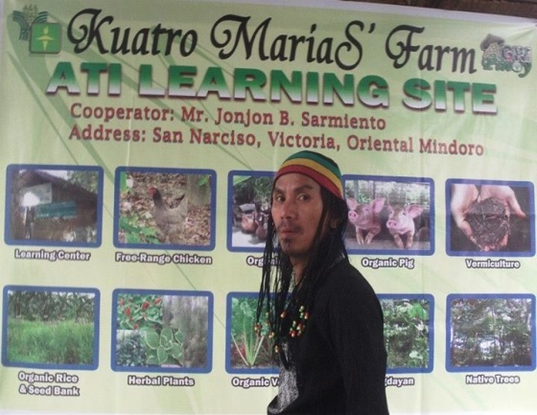

Jon Sarmiento, 40 years old, is born of a farming family in Mindoro, Philippines. As a young entrepreneur, he developed his farm ten years ago using the Integrated, Diversified , Organic Farming System (IDOFS) farm planning and implementation and full value chain agri-business enterprise development with actual farms, clusters, cooperatives to demonstrate to others as models. Jon had received various trainings from NGOs and church workers. Now his farm is a learning center, where visitors can stay for several days and see and learn about raising organic pigs, chicken, planting organic herbal plants and vegetables, native trees, composting, as well as vermi-culture. IDOFS is mainstreamed as the core of the Sustainable Agriculture Program of PAKISAMA.

One training activity which Jon regularly conducts in his learning farm is the Y.E.S. (Youth. Ecology. Sustainable Agriculture) camp for young people, including young farmers. Because of his home-grown and successful experience, he is one of the most sought after farmer-extensionist, and his farm is an accredited learning center of the Department of Agriculture.

**BOX 2**

**New Farmer Program in Tainan City, Taiwan**

Currently enrolled in the program are 268 young farmers (14% women), all under 45 years of age, currently farmers or aspiring to be farmers. The government extension unit provides technical and financial support to these young farmers. Technical support is provided through experts, apprenticeship, agriculture courses, and counselling system. The agriculture experts and masters who teach agriculture to young farmers are deployed through the district farmers’ associations. Financial support comes in the form of government loans with low interest to young farmers to buy facilities, supplies or equipment. Several new farmers were successful, became young millionaire farmers, and won competitions such as in organic rice and organic cherry tomato production.

**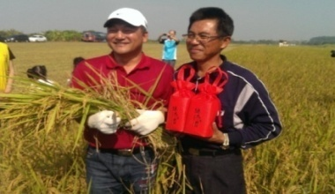**

Mr. Don, 42 years old

* Planting rice, cherry tomatoes, jujubes
* Through Tainan City Government, his 2.5 ha organic ice was contracted with a construction corporative for the provision to the company’s employees’ consumption and gifts.

**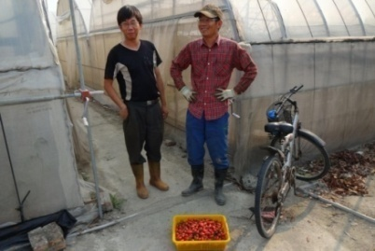**

Mr. Wang, the young brother, 35 years old and his older brother on the right, 41 years old

* Planting cherry tomatoes
* Former engineers before their farming business
* 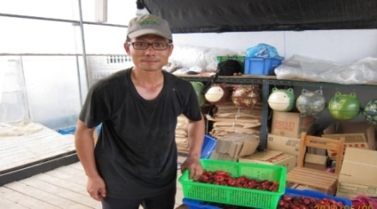The young brother has won the reward “National Healthy and Quality Facilities for cherry tomatoes competition” in the past two years.

Mr. Wu, part-time farmer, 43 years old

* Growing cherry tomatoes and vegetables
* Working in Uni-President Corporative
* Aspiring to learn planting skills and agriculture production practices
* 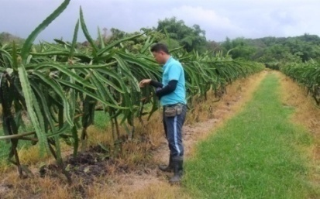Aiming to grow organic, toxin-free agriculture produce.

Mr. Wang, 31 years old.

* Growing Dragon Fruit on 6 ha land
* Full-time farmer after completing his education
* Working hard to learn agriculture practices and become a new and innovative farmer.

**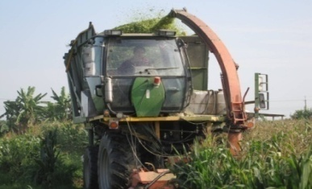**

Mr. Chen, 39 years old, second generation farmer

* Planting grains (Maize, Black Pea), 60 ha
* Leader of grain production and marketing group
* Pioneer of small landlord and big tenant policy
* Maize land scale grew from 23 ha in 2011 to 56 ha in 2013

**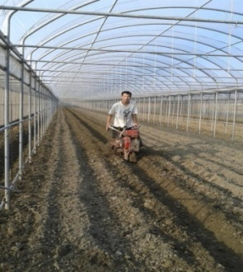**

Mr. Chen, 26 year old, second generation farmer

* Planting melons on 1 ha land
* Become farmer after military service
* Planting balsam pear (bitter melon)
* Providing fruit picking camp, also work with biotech R & D corporative for bitter melon capsule and lozenge sales.

**2. Debate on family farming.** The influx of multinational companies, land grabbing, and corporate farming led to an increased debate on family farming and peasant economy. The UN celebrated the International Year of Family Farming in 2014 and most FOs, CSOs and government agencies supported this. FOs and CSOs working on agriculture and food started debating and influencing policy on family farming, sustainable, agro-ecological approaches and increasing market power of family farmers. The focus on family farming has contributed to a special attention to youth in agriculture, and AFA members have greatly contributed towards these efforts.

**3. Development of sustainable, agro-ecological, organic farming.** People started to prefer organic food towards a healthy lifestyle. As a result, the number of organic farms has increased. The positive aspect of this scenario is that mostly the youth are involved in the promotion of organic farm, and their interest is increasing. For them, organic farming provides some meaning in their work, more opportunities to do innovation and learn from old and new ways of farming. Some governments have provided support to promote sustainable, agro-ecological and organic farming, thus attracting more youth in agriculture. In South Asia, returning migrants from the Gulf started farming and some of them are promoting organic farming as well. (see Box 3.)

**BOX 3**

**Supporting Young Organic Agricultural Farmers in Japan**

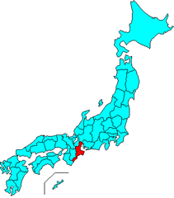Six new young organic farmers, one of them a woman, had an average gross profit of 8,860, thousand yen in 2013, an increase by 207%.

The young farmers have an average farming experience of 8.4 years and cultivate a total area of 13.6 ha of vegetables (tomato, spinach, cabbage, etc) in greenhouses. There was an increase in area by 161%.

They attributed their success to the sufficient support – skills, land, house, and markets - given to them by their farmer- trainers. The new young farmers acquired their agricultural skills through: training by fellow senior farmers, farmers in the nearby region, government extension providers; participation in training courses; reading books; and internet. They became independent within a short period, after which they trained other newcomers. Also, they strengthened cooperation and became increasingly organized with the support of three major organic agricultural groups. They got their customers in three main ways: referrals (by senior farmers, shippers groups, and friends), self-seeking, and internet.

*Factors necessary to increase the number of young farmers:*

* Introducing / securing markets for the new farmers for the first 3 to 5 years;
* Stable income for the first 3 to 5 years is required for the continuous engagement in agriculture. Therefore it is necessary to secure sale destination in the beginning;
* Securing abundant human recourses in agricultural sector by continuous acceptance of trainees;
* Overall support for the new farmers / trainees by providing market / land / house / skills and the new farmers become trainers when settled;
* Up skill training and development of new markets by the cooperation of the several agricultural groups; Stronger relationship has been achieved by setting up the new association;
* Facilitating activities by organization of the groups and cooperation with administrative agency, simplifying and support for the application;
* Abundant information about trainer farmers;
* Agricultural skills based on scientific evidence and other farm management.

**4. Building Young Farmers Organizations (FOs).** CSOs and even UN agencies have been facilitating the process of forming FOs, mobilizing them for policy change and farming. Farmer organizations have started to form their youth wing. Debates and discussions have focused on farmers' rights and initiatives.

* ***Mongolian Young Herders Committee.*** The Mongolian Young Herders Committee was established in 2013 to protect the interests of young herders. It organized a national consultation in February 2014 attended by youth herders across Mongolia’s 21 provinces. The Committee has been working on a national level survey questionnaire about young herders. Another organizations is the Young Cooperators Club established in 2010, which successfully organized the *First Meeting of Cooperative Young Leadership in Agriculture* in 2013. Several NGOs also work on youth issues such as the Mongolian Youth Federation (MYF), the largest NGO in Mongolia which aims to be a voice for youth advancement and rights protection.
* ***FNN Youth committee***. In Cambodia, the Farmer and Nature Net (FNN) has established a youth committee which is represented in its board. The young farmers are also being developed into young leaders and farmer entrepreneurs through exposure to demonstration farms and good farming practices such as building a fish pond, growing organic rice, applying multipurpose farming, raising livestock, and using manure to produce biogas.
* **PAKISAMA Young Farmers Assembly.** In the Philippines, PAKISAMA organized its youth arm which have become strategic targets of its training programs. The young farmers assembly have elected their own set of officers which will be represented at future organizational meetings of PAKISAMA.

**5. Promotion of women farmers.** As more and more rural men migrate to cities and abroad, agriculture has become feminized and debates on women farmers’ rights and access to land have begun. Women farmers have been actively involved in advocating for their rights. In some countries, including Nepal, women farmers' forums have been formed, while in others, e.g. Philippines, young women farmers are being groomed to be among the next generation of farmer leaders (see Box 4).

|  |
| --- |
| **Box 4**  **The Story of Ana, a Young Woman Farmer**  Ana, 24 years old, is a daughter of a farming couple, from Mindoro Oriental, Philippines. 1381536_512605285500514_2146011433_n.jpgShe has finished a commercial cooking course, but she loved farming and wanted to have her own farm and manage her own farm business. She attended a training on Integrated, Diversified Organic Farming Systems (IDOFS), given by PAKISAMA, a national farmer organization in the Philippines. After her training on IDOFS in 2014, Ana convinced her family to convert their 2,500 square-meter farm into an IDOFS farm. She started to build a vermi-compost, a fishpond, a vegetable garden, and raise free range chickens. She made optimum use of every square-meter of their family farm. She is now promoting IDOFS farm planning to other young farmers in their neighborhood and beyond. She was awarded as one of the model farmers during the Philippine celebration of the International Year of Family Farming (IYFF).  (also see: <http://www.philstar.com/agriculture/2015/01/04/1409144/magna-carta-young-tillers-urged>) |

**6. Evidence-based advocacy on comprehensive policy for family farmers.** AFA farmers organizations in countries such as in Indonesia, the Philippines and Nepal have been organizing a series of debates and discussions on comprehensive land and agrarian reform policies, including on land ownership, access to agricultural inputs, devolution of land administration, and formulation and implementation of land use and farmers' rights policy. FOs and CSOs have been actively involved in these activities. Farmers have been mobilizing themselves in advocating for policy change on land and agrarian reform on behalf of young farmers. Some FOs, CSOs and UN agencies in countries such as Nepal, Mongolia, Cambodia, the Philippines, Indonesia, Bangladesh, and Vietnam, have been conducting research and case documentations for policy advocacy for young farmers. They use the research findings and cases to influence their respective governments and policy makers. Gradually, INGOs and bilateral organizations have been moving towards supporting young farmers and investing in agriculture.

In Indonesia, API is promoting the participatory breeding of local seeds which is of the same quality as those bred by private companies but is 70% cheaper (see Box 5). In Korea, KAFF is proposing a package of policy reforms that will ensure succession in family farms by lowering interest rates to young farmers and exempting them from military service, among others (see Box 6). In Japan, AINOUKAI is suggesting to encourage newcomers to agriculture by, among others, providing financial incentives and payments to young farmers to achieve stable incomes for the first 3-5 years, helping them acquire agricultural skills and shift to organic farming (see Box 3), and promoting such schemes as “*Family Management Agreement*” which has also created better working conditions for rural women (see Box 7). In the Philippines, PAKISAMA is proposing to enact a “*Magna Carta of Young Farmers”* to promote and protect the rights of young farmers 15-40 years and put pride and dignity back in farming and introduce innovative programs such as “farm take-over” that will provide capital to young farmers to enable them buy their parents’ lands.

**BOX 5**

**The Story of Rifai: Participatory Breeding of Local Seeds in Indonesia**

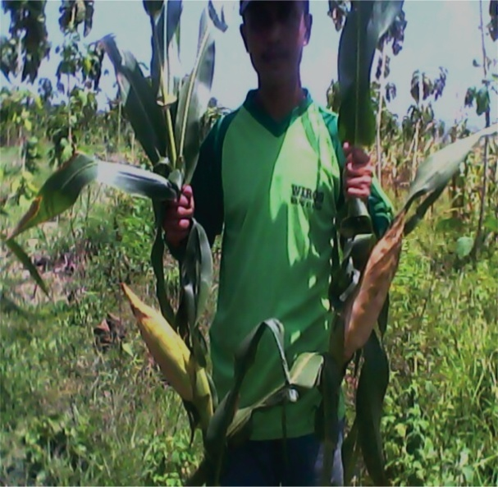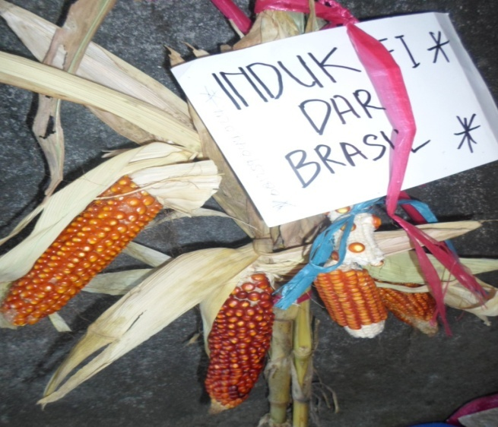

Muhammad Rifai, 31 years old and father of one son, has been cross breeding Brazilian, Mexican and Indonesian corn seeds which were exchanged to him during an international conference he attended in 2009. He has been sharing this knowledge among young and elder farmers through “musyawarah” or popular discussion, and is now gaining customers by selling his locally-developed seeds which is of same quality but is 70% cheaper than private company seeds.

Rifai has been working with API for only 3 years when he began his search for the ideal seeds of corn. Peasants have found the price of corn seeds produced by a private company very expensive which also makes the peasants become more dependent on the seeds. They are also hybrid seeds, and suspected as transgenic which harm the environment and health of all.

In 2009, Rifai started his searching, collecting, and selecting the best local corn seeds. He then participated in the event of ITPGRFA (International Treaty on Plant Genetic Resources for Food and Agriculture) held in Bali where he met other representatives of farmers from Brasil and Mexico. Then Rifai exchanged seeds with them.

Rifai disseminated the excellent seeds he has grown (local and foreign) to corn farmers of Kediri, East Java. Then the farmers cross-bred and propagated the seeds, and planted them in large scale. Rifai has been sharing this new knowledge among young and elder farmers through “musyawarah” or popular discussion.

Based on their two years of experience in developing the ideal corn seeds, Rifai and other farmers found that the quality of their seeds is the same as the quality of seeds produced by the private company. While the seeds they developed is resistant to “bulai” disease (the leaves become white due to fungi infestation), on the contrary the seeds produced by company is susceptible to the disease. The seeds developed by farmers is also 70% cheaper than the private company’s seeds.

Rifai has now gained customers from three subdistricts of his hometown in Lamongan District in East Java province. There is also increasing demand for his corn seeds from Gorontalo Province (Sulawesi), which is the center of corn in eastern part of Indonesia, by as much as 40 tons from Kediri corn farmers. In Bali, there is also demand to experiment with the local seeds, Rifai and his group then facilitated Balinese farmers to have 30 kg of seeds ready to be planted for trial to see the feasibility of the corn seeds, and find their own seeds.

Until now, Rifai has been planting, developing the best local seeds, the Brasillian and Mexican corn in his hometown. He is growing four (4) varieties of two local varieties of “Siliantang” and “Asmorodhono”, and the two (2) foreign varieties from Brasil and Mexico.

|  |
| --- |
| **Box 6**  **Young farmers in Korea**  According to the Korean Advanced Farmers’ Federation (KAFF) and the Women Advanced Farmers Federation (WAFF), although there are many problems in the agricultural sector, there is hope. As a response to the growing problem of corporate take-over of farmlands, the government has regulated ownership of land such that only those who have been farming for five years are allowed to own lands in rural areas.  To address the needs of farmers affected by FTAs, the government has developed a policy to ensure that industries which gain from FTAs support agriculture through a fund that allows these industries to invest their profit in agriculture. More recently, Korean rice farmers have been able to negotiate that all losses that they would incur due to FTAs would be compensated by government.  It is deemed the duty of government to ensure the survival of Korean farmers. KAFF has proposed a policy that will: (1) ensure succession in family farms by providing endowment, technological support and education to promote better eco-system of farmers; (2) exempt young farmers from military service; (3) provide financial support to young farmers by lowering interest rates from the current 3% to 1% and adopting a credential recognition system; (4) enable members of Youth Farmers Association to actively participate in KAFF activities; and (5) maximize social responsibility of young farmers and develop their capacity as local farming leaders. |

**BOX 7**

**Family Management Agreement in Japan**

Although the family management agreement is a new concept, it has gradually become popular all over Japan. In 2006, the Ministry of Agriculture, Forestry and Fisheries conducted a survey on the status of the Family Management Agreement. It showed that since its implementation in 1995, more than 30,000 farm household members have already signed the agreement.

Farmers appreciated the family management agreement as it gave their successors incentives and made them more aware of their responsibilities; the successors on the other hand found it worthwhile and less stressful to work at their father's farm. The Family Management Agreement has also been used to advance women’s roles as partners in the overall farm management and improve their situation as farm and domestic workers. For young farmers, it was a way to appreciate farming better and become more knowledgeable of farm operations and participate in management policies.

The family management agreement has brought about the following achievements:

Farm activities have improved. For example, the successors or young farmers freely introduced new ideas such as the use of personal computers for book keeping or/and hiring temporary workers like students or housewives in the farm management.

The meaningless conflicts due to differences of opinion between the father and the son has been eliminated.

It enables the family members to discuss any problems frankly and to reach a consensus on all the important matters of farm management and farm household.

It encourages the establishment of individuality of each family member (e.g., independent participation and having an opinion) and the formation of the partnership which further promotes participation in the farm management.

It draws a clear-cut line for protecting the rights of family members as it has changed the characteristics of the family farm from a paternalistic one to a business like one.

A smooth transfer of farm management has been made possible. Usually, the farmer transfers his management right in his age of 60s. However in the case in which the family management agreement has been signed, the intergenerational transfer is carried on gradually and successfully.

It has contributed towards a gender-equal society by serving as a pathway for creating better working conditions for rural women.

*Sources: Iwamoto (1996) and Abe (no date)*

**VII. AFA POLICY PROPOSALS TO ATTRACT YOUTH BACK INTO FARMING**

AFA member FOs have put forward the following policy proposals to attract youth back to agriculture.

|  |  |
| --- | --- |
| **Policy Proposals on Youth in Agriculture by AFA members** | |
| **API , Indonesia** | Promote family farming and incentives for young farmers through national laws such as “*Protection and Empowerment to Farmers”* that promote access to capital and markets, price protection for small farmers, participatory crop breeding, and knowledge-sharing among young and elder farmers through “musyawarah” or popular discussions. |
| **PAKISAMA, Philippines** | Enact a ““*Magna Carta of Young Farmers”* to promote and protect the rights of young farmers 15-40 years and put pride and dignity back in farming and will define discrimination against young farmers, institutionalize young farmers’ representation in all agricultural policy-making bodies, and introduce innovative programs such as “farm take-over” that will provide capital to young farmers to enable them buy their parents’ lands. |
| **VNFU, Vietnam** | Promote farmers’ access to markets, provide training and technology transfer, long-term investment and credit support, organize exchange visits and develop models on production and business for rural youth, and build respect for farmers by raising awareness on the role of farmers and agriculture. |
| **FNN, Cambodia** | Prioritize agricultural education program for the youth and develop programs for youth in agriculture with NGOs and the private sector. |
| **KKM, Bangladesh** | Establish model cooperative farms by organizing smallholders farmers, develop skills of rural youth through agricultural education and field-based training, establish agricultural research centers and universities, introduce “land banking”, provide agricultural credit to young farmers’ coops at low interest rate and easy terms, promote eco-friendly mechanization of agriculture, conduct awareness campaign to motivate young farmers to grow respect for farming, and promote integrated family farming. |
| **NLRF, Nepal** | Increase investment in family farming, conduct research on the situation of family farming, involve the youth in ensuring farmers’ rights in the new Constitution, create a new network of young farmers, and create more public awareness on the importance of family farming. |
| **NAMAC, Mongolia** | Protect young herders’ and farmers’ social security, improve their living and working environment and increase their household incomes, equip unemployed youth with transferable herding/animal husbandry skills, identify problems faced by youth in the agricultural industry and ways to solve them, promote the movement of “*New Generations of Herder Volunteers*”, and boost the dignity and leadership of youth in agriculture. |
| **UWUA , Kyrgystan** | Provide state support to young farmers, rural women and rural development, train young farmers in contemporary farming techniques (e.g. integrated water resources management) and set up demonstration plots, experience exchange and farmer field schools, enhance professional training of farmers, provide young farmers with long-term credit with low interest rates and simple procedures, set up information centers with agricultural product sale database, promote young women farmers in executive posts, and support the formation of youth organizations in rural areas. |
| **KAFF, South Korea** | Ensure succession in family farms by providing endowment, technological and educational support towards better ecosystem of farmers, replace or exempt young farmers from military service, provide financial support to young farmers by lowering interest rates from 3% to 1% and adopting a credential recognition system, enable the active participation of young farmers in civic activities, and develop the capacity of young farmers to be local farming leaders. |
| **TDFA/TWADA, Taiwan** | Provide support to young farmers through schemes such as “*New Farmer Program”* that encourages new farmers to participate in agriculture through technical and financial support in the form of government loans with low interest, promote sustainable agriculture banking to activate fallow land and help new farmers to expand production scale agriculture. |
| **AINOUKAI, Japan** | Encourage newcomers to agriculture, provide financial incentives and payments to young farmers to achieve stable incomes for the first 3-5 years, help young farmers secure markets, acquire agricultural skills and shift to organic farming, reflect the voice of young organic farmers, raise consumer awareness about food safety and organic foods, promote cooperation among young farmers and support from local community through food purchase schemes, and promote such schemes as “*Family Management Agreement*” where family members agree on their roles and tasks in the farming operations, young farmer successors are given more incentives to farm and better knowledge of farm operations, and which advances women’s roles as partners in overall farm management. |

Attracting the youth back to agriculture can also benefit from the experience of programs being implemented in the European Union (Direct Payment, Setting Up Young Farmers, etc), proposals from “Bordeaux Manifesto” (agricultural banks, intergenerational apprenticeships for young farmers, etc), Australia (Next Generation Program), and the United States (tax incentives, etc):

* **European Union.**Promote EU policies for financial assistance or subsidies to encourage the youth to choose a farming career through “*Direct Payment Policy”, “Setting up young farmers”* providing aid of up to €70,000, “*Modernizing farm holdings”* and “*Early retirement”* to encourage farmers to transfer their holdings to the youth. Provide increased installation aid and annual “top-up” payments to young farmers during the first years after installation to enable them to start or take over a farm and address barriers such as **access to land and bank loans.**
* **Bordeaux Manifesto.** Promote social, economic and legal recognition of family farmers, promote young farmers’ installation and set up specific support measures in favor of family farming, such as support the creation of cooperatives of young farmers or creation of youth sections in existing cooperatives; national agricultural policiesthat support education and training programs for young farmers; access to land and credit with low and flexible interest rates; intergenerational cooperation and apprenticeships for young farmers; land transfers; and “agricultural banks.”
* **Australia.**Establish a *“Next Generation Program”* that will promote succession planning to help finance family farms as they transition from one generation to the next and provide grants for communities which are experiencing or are at risk of social isolation to give community members a sense of belonging.
* **United States.**Address issue of rising land prices and young farmers no longer able to afford loan through such schemes as **succession planning, p**roviding tax incentives for landowners who rent or sell land to beginning farmers, and making state lands available through contract, lease or purchase programs to beginning farmers.

(Please see Annex N for more information on the programs.)

**VIII. WHAT CAN OUR GOVERNMENTS DO TO ATTRACT THE YOUTH TO AGRICULTURE AND MAKE THEM STAY?**

Based on our interviews and observations with the rural youth, our reflection is that the youth can be attracted to agriculture if: (1) agriculture will earn enough for them to raise a family, (2) they are provided basic resources such as land, capital, training, farm equipment and market and (3) they can see meaning and significance in their agriculture work.

If taken, the following recommendations or action points will allow young farmers to help propel their respective countries to become self-reliant on food, and contribute to sustainable and inclusive growth. These recommendations have also been inspired by the successful initiatives mentioned above.

1. Provide young farmers with ownership or use or lease rights of farming lands for at least 25 years. Without long-term land security, youth will not be interested in farming in their respective villages.

2. Provide special and integrated agricultural programs and support services to young farmers, including education, training and extension, leadership training, credit, technologies, agricultural inputs, appropriate equipment and machineries, subsidies, insurance, and markets. School curricula should encourage agriculture as a profession. Young farmers can be trained as young rural entrepreneurs, focusing on sustainable, agro-ecology based production and processing and setting up of agriculture multi-purpose cooperatives; as these provide added meaning and cultivate idealism in their lives. Provide public recognition to outstanding young farmers, e.g., those who were able to successfully help in building agriculture cooperatives. Young women farmers should also be given special focus as often in the rural areas they are more marginalized by existing social structures and practices, yet have the potential.

3. Provide avenues wherein young farmers can organize themselves, learn from each other and participate in decision-making and policy formulation processes. Young people need to feel a sense of ownership of policies and programs concerning them. Conduct exchange and knowledge visits among young farmers intra and inter-country. Set up information centers for the youth.

4. Improve infrastructure and peace and order situation in rural areas, as well as provide social security and protection for young farmers.

5. Farmers in the Asia Pacific region are family farmers, who are the poorest and hungriest in the world. Supporting the family farmers now through a comprehensive and integrated policy and program on agrarian reform, rural development, sustainable, agro-ecological approaches, and markets and trade will increase incomes and resilience of farmers, thereby changing young peoples’ views about farming.

**IX. WHAT CAN AFA DO TO PROMOTE AGRICULTURE AMONG THE YOUNG?**

**1. Policy advocacy.** Most Asian farmers are concerned about policy issues. AFA can develop and promote policy proposals to attract youth to agriculture, e.g., secure access to land, capital and other resources; soft loan and financial support to young farmers; New generations of Herder Volunteers; New Farmers Program;farm take-over schemes; etc. AFA can facilitate for common regional issues, such as on neo-liberal policy, WTO in agriculture, climate change, free trade, land grabbing, rights of young and women farmers, social security, and AFA regional farmers’ associations can lobby with UN agencies and bilateral organizations on farmer-friendly policies, programs, and support.

**2. Capacity building**. The youth needs appropriate training and exposure through education, as well as the presence of mentors, coaches, motivators, to motivate young farmers. The youth needs to be attracted to sustainable, organic, agro-ecological approaches, farmer-owned and led enterprises and value addition. An entrepreneurial attitude should be built among young farmers. They also need to be trained on constructive engagement and be provided with youth education, scholarship programs and ensure admission of especially women in agricultural universities. Methods like “learning by doing” or “farmers train farmers” can also be used. AFA should also take note of the innovativeness of young people and a growing interest of young people in becoming agronomists, agri-preneurs, chefs and cooks, etc.

**3. Young farmer exchange programs.** AFA members and other FOs have developed sustainable agricultural models. AFA can facilitate the process of young farmers’ exchange programs; knowledge building of farmers on agriculture farming, new technology, new policy formulation; cooperation and international solidarity among young farmers; participation in trade fairs, exhibition; competition on farming techniques; sharing success stories of youth involvement in agriculture, etc.

**4. Alliance building among FOs.** Land and agricultural issues are political issues; they can only be solved through political means. Therefore, it is important to engage concerned governments through community mobilizations at the national and international levels. In this regard, AFA can facilitate the process of alliance building among FOs and CSOs towards such mobilizations.

**5. Partnership with various actors.** Sustaining family farming and youth in agriculture is not possible without financial and technical support. Thus, AFA can facilitate the process of partnership among more sustainable FOs with CSOs working in the field of agriculture and donors supporting and promoting agriculture in different regions and countries. There is a need to link up with various actors (government, business sector, banks, academe, consumers, etc) to set up links with training centers and refresher courses; link up with consumer groups on about food safety and organic foods; create support from the local community for food purchase schemes.

**6. Research and publication.** Research and publication on agricultural, family or youth farming is an important area. A number of issues require study and dialogue with respective governments or donor agencies. AFA can directly conduct research and dialogue at the regional level and provide support on these at the country level. Further research needs to be done on effective strategies to attract youth to agriculture, e.g. comparative study of the use of organic and non-organic fertilizer, policy research on incentives for young farmers, research on impacts of climate change. The lack of a common definition or official data on young farmers should also be addressed. Action research such as participatory breeding of local seeds should also be documented, as well as success stories of young farmers as role models and promoting the rights and effective participation of young women in agriculture.

**7. Building and strengthening young farmers organizations.** The key to enticing the youth into farming is forming a strong base of organized young farmers who are empowered to negotiate for support that they would need to nurture a happy and healthy world. The youth needs their own spaces to find their voice and actualize themselves as young farmers. They need more venues for more participation and representation at all levels, including establishing a youth arm at AFA, to give voice to young farmers, strengthen cooperation groups / cooperatives, to organize support to advocacy work, and to develop knowledge networks. The creation of cooperatives of young farmers or creation of youth sections in existing cooperatives and producer groups, workers’ associations, savings groups and women’s groups, should be supported. Moreover, organizing and strengthening small-scale family farmers will make them better prepared to access opportunities and benefit fully from ASEAN or other free trade integration and address adverse consequences as a result of integration.

**X. CONCLUSION**

The youth can be attracted to agriculture if they see meaning, income opportunities as well as feel a sense of pride in farming. The youth needs training, as well as the presence of mentors, coaches, motivators. The youth needs to be provided with basic resources especially land, capital and equipments to make farming less tedious work.

To harness the potentials and energy of the youth for agriculture, a comprehensive and integrated policy and program on agrarian reform, rural development, sustainable, agro-ecological production and farmer-managed agro-based enterprises as well as on markets and trade should be put in place, with special incentives and provisions for young farmers, especially women.

The community and the larger public must be sensitized to the importance of the role of agriculture in the economy and in ensuring food security. Respect for farming should be built and more awareness should be created in recognizing the role of farmers and agriculture, and in ensuring the next generation of farmers through the succession of young farmers.

The youth is the future of the nation, and the rural youth is the future of agriculture and rural industry. The time to act is now, if we would like to have farmers, and food, in the future.

**REFERENCES**

AFA (2014 a). Attracting Youth to Agriculture in Asia: Context and Prospects. A Regional Scoping Paper Prepared by the Asian Farmers’ Association for Sustainable Rural Development (AFA). December 2014.

AFA (2014 b). Proceedings of the 6th AFA GA and Regional Consultations: “Seizing the Momentum to get Concrete Gains for Small Scale Farmers this IYFF.” May 6-8, 2014. Hotel Santika, Bali, Indonesia.

AFA 2014 c). AFA Young Farmers’ Regional Forum and Workshop: “Building the Development Agenda of Asian Young Farmers.” 25-26 November2014, Brentwood Suites, Quezon City, Philippines.

AFA (2014). Various Country Papers on Youth in Agriculture through FACT, by AFA members, 2014.

AFA 2015. “ A Viable Future: Attracting the Youth Back to Agriculture”, August 2015.

Ahmad, QaziKholiquzzaman et. Al. (2010). Learning from Reforms in Agrarian Structures and Prospects of Cooperation in Agriculture in South Asia. Economic Integration in South Asia, Issues and Pathways. Delhi: Imagine New South Asia.

Araghi, F. A.(1995). *Global Depesantization 1945-1990*. USA: The sociological Quarterly, Vol. 36, No. 2 (Spring 1995). Retrieved from <http://www.polsci.chula.ac.th/jakkrit/anthro/Rural_Sociology_files/Global%20Depeasantization,.pdf> pp.337-368. Accessed on 20 October 2012.

Borras, S.M. (2006). *The underlying assumptions: Theory and practice of neo-liberal policies,* Retrieved from <http://www.foodfirst.org/files/bookstore/pdf/promisedland/5.pdf> and accessed on 7th January 2014.

David Kesmodel and Tony Dreibus, *Sowing a New Crop of Farmers*, Wall Street Journal, November 11, 2014 <http://www.wsj.com/articles/young-farmers-emerge-as-the-new-sharecroppers-1415646900>

Danielle Nierenberg, President, Food Tank, *Cultivating a revolution in agriculture for young people,* In*:* “Deep Roots” (Food and Agriculture Organizations), 2014

European Parliament's Committee on Agriculture and Rural Development, *EU Measures to encourage and support new entrants,* September 2012

<http://www.europarl.europa.eu/RegData/etudes/note/join/2012/495830/IPOL-AGRI_NT%282012%29495830_EN.pdf>

European Network for Rural Development (ENRD), *Youth and Young Farmers Gateway,* <http://enrd.ec.europa.eu/enrd-static/themes/youth-and-young-farmers/en/youth-and-young-farmers_en.html>

European Council of Young Farmers (CEJA), Conference on "Sowing the Seeds to Harvest in Future: Supporting Young People into Farming", Brussels, 12 April 2012, <http://www.ceja.eu/>

Kees van der Geest, FAO, *Rural Youth Employment in Developing Countries: A Global View,* March 2010 <http://www.fao.org/docrep/W1765E/w1765e07.htm>

Georgie Aley, Future Farmers Network - Australia, “*The future of Family Farming: empowerment and equal rights for women and youth*”, July 9, 2014 <http://www.fao.org/fsnforum/forum/discussions/family-farming>

Harvey, D. (2003). *The New Imperialism.* London: Oxford University, University Press.

Hu, J., Yeh, A., Wu, F. (2009). *Land commodification: New land development and politics in China since late 1990s.* International Journal of Urban and Regional Research, Volume 33. 4 December 2009, 890-913. Retrieved from <http://www.grm.cuhk.edu.hk/eng/research/RAE2011/XuJiang/2_IJURR_2009.pdf> and accessed on 14 January 2014.

IIED (2012). *Small-scale farming and youth in an era of rapid rural change.* Retrieved from <http://pubs.iied.org/pdfs/14617IIED.pdf> and accessed on 7th of April 2015.

International Fund for Agricultural Development (IFAD) (2011), *Feeding future generations: Young rural people today – prosperous, productive farmers tomorrow,* February 2011 <http://www.ifad.org/events/gc/34/panels/proceedings.pdf>

International Young Farmers’ Manifesto, *“To make family farming a solution for the future”,* Bordeaux, France, 4 September 2014 <http://www.nfyfc.org.uk/document.aspx?docid=31099>

Izumi Iwamoto, *The Role of Family Management Agreement in Japan,* Presented at the Second Asian Conference of Agricultural Economists, Bali, Indonesia, August 6-9, 1996 <http://www5d.biglobe.ne.jp/~iamarock/iwamoto/paper/agreement.pdf>

Japan Times editorial, *How will Japan’s farms survive?* June 28, 2013 <http://www.japantimes.co.jp/opinion/2013/06/28/editorials/how-will-japans-farms-survive/#.VLO53dKUf4E>

Kumar, A. (2011). *Land in the neo-liberal times: A commodity or social good.* Institute of Town Planning, India Journal 8-208, April -June 2011, Retrieved from <http://itpi.org.in/files/apr2_11.pdf>and accessed on 17th January 2014.

Orti Despuez*, Migration of rural youth to urban centers may compromise food security – Searca*, InterAksyon.com, February 12, 2013 <http://www.interaksyon.com/business/54922/migration-of-rural-youth-to-urban-centers-may-compromise-food-security----searca>

Peters, David J. (2002). *Revisiting the Goldschmidt Hypothesis: The Effect of Economic Structure on Socioeconomic Conditions in the Rural Midwest*. Missouri Department of Economic Development, Technical Paper. P-0702-1, (Jefferson City: Missouri Department of Economic Development, 2002).

Shrestha, N. (2001). *The Political Economy of Land, Landlessness and Migration in Nepal.* Nepal: Nirala Publications.

Sumiko Abe, Japan Agricultural Development and Extension Association (JADEA), *Family Management Agreement: The Experience of Rural Areas in Japan* (no date) <http://www.agnet.org/htmlarea_file/library/20110726142013/eb595a.pdf>

UN ESCAP, *Youth in Asia-Pacific Fact Sheet*, November 2012 <http://www.unescap.org/resources/youth-asia-pacific>

UN ESCAP, *Regional Overview: Youth in Asia and the Pacific* <http://www.un.org/esa/socdev/documents/youth/fact-sheets/youth-regional-escap.pdf>

UN ESCAP, *Statistical Yearbook for Asia and the Pacific 2013* <http://www.unescap.org/stat/data/syb2013/>

United Nations Foundation (2011). *Largest youth generation in history at crossroads*. 25 February 2011. Retrieved from <http://www.unfoundation.org/news-and-media/press-releases/2011/largest-youth-generation-in-history-at-crossroads.html?referrer=https:/> and accessed on 17 January 2015.

Wobst, P. (2010). *Promoting Employment and Entrepreneurship for Rural Youth:  
The Case of the Farmer Field and Life Schools (JFFLS).* 19th CTA Brussels Rural Development Briefing - 16 June 2010.

1. <http://www.ilo.org/wcmsp5/groups/public/---ed_emp/documents/publication/wcms_182750.pdf> [↑](#footnote-ref-2)
2. <http://www.fao.org/docrep/012/al414e/al414e00.pdf> [↑](#footnote-ref-3)